**Mainframes DXC Australia**

**Assessment 8: Storage**

**By: Pranay Yara**

**23/08/2024**

**PDS: USERID.WEEK8.TEST (Create all members inside this PDS)**

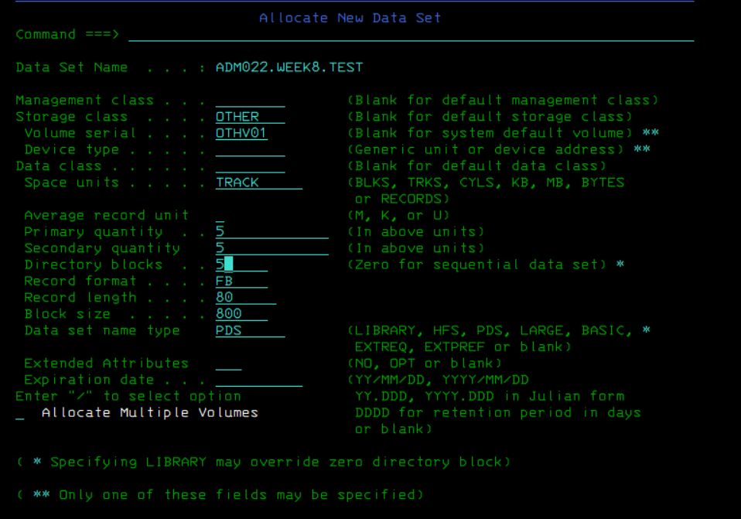

**1) Identify and list any 5 SMS and Non-SMS Managed Volumes available in the Server in a Member inside the PDS**

M > 2(ismf) > 2(volume) > 1(dasd) > Volume Serial Number . . * > enter

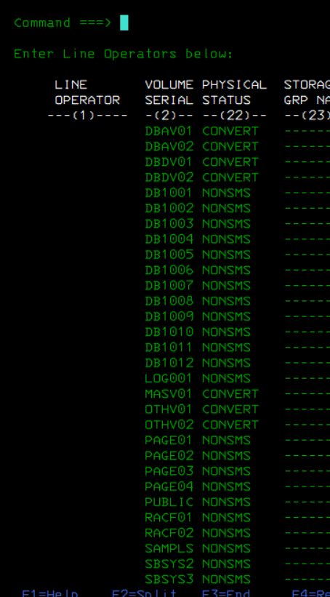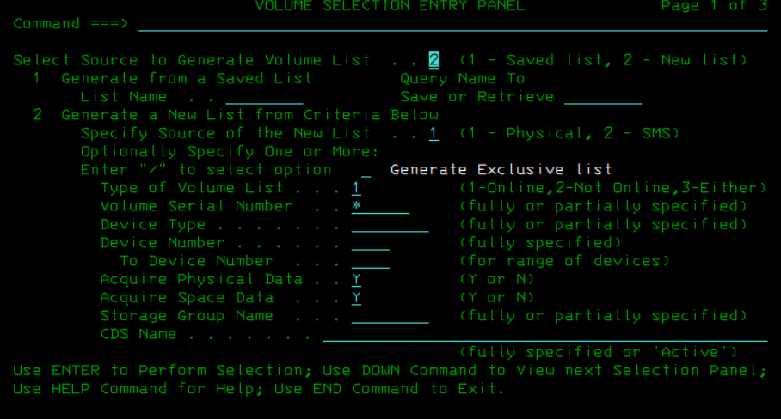

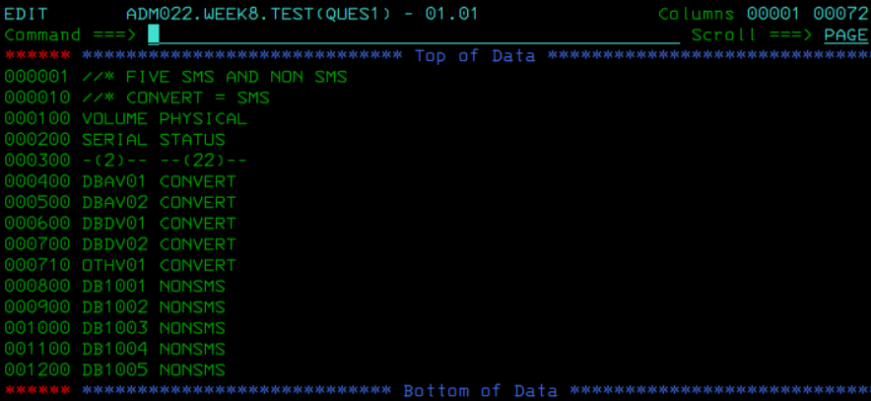

**2) Create a PDSE using 3.2 using IEFBR14**

I did try this question with DSORG=LIBRARY but I kept facing the error “3 IEF643I UNIDENTIFIED POSITIONAL PARAMETER IN THE DSORG SUBPARAMETER OF THE DCB FIELD”. So, I used dsorg as p0 and dsntype as library which ended up working.

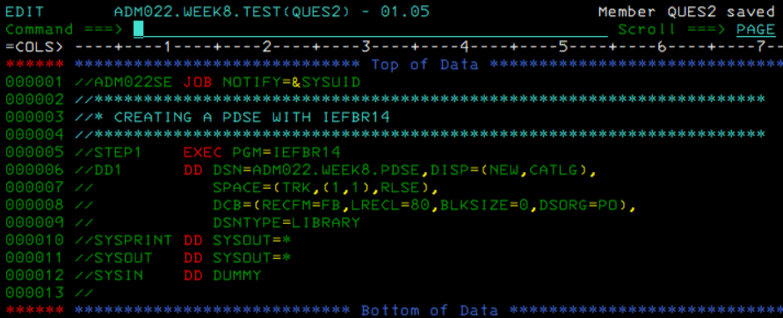

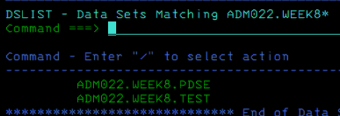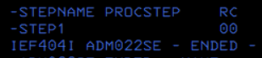

**3) Create a KSDS with key in columns 11-20 using IEFBR14**

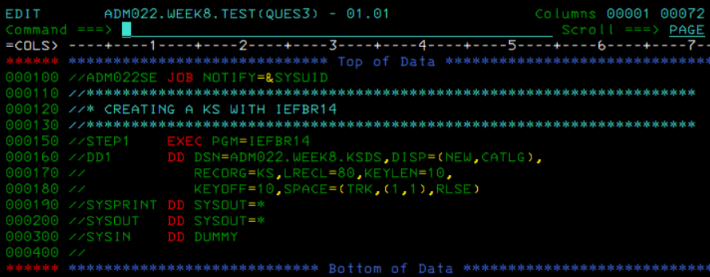

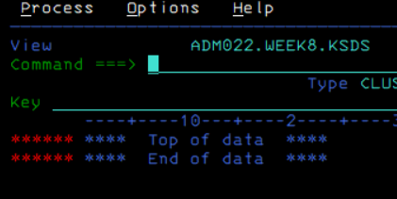

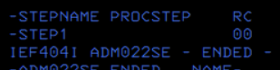

**4) Copy member BUILDSGR from SYS1.SMS.CNTL to your PDS and do the following**

**Assign a Storage group as 'GENTEST' if Storage Class is 'GENTEST'**

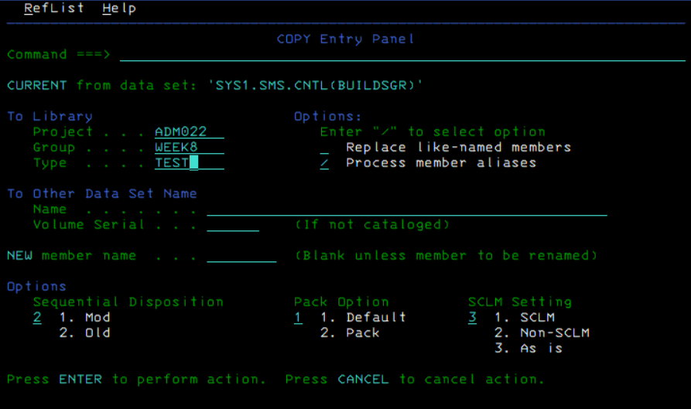

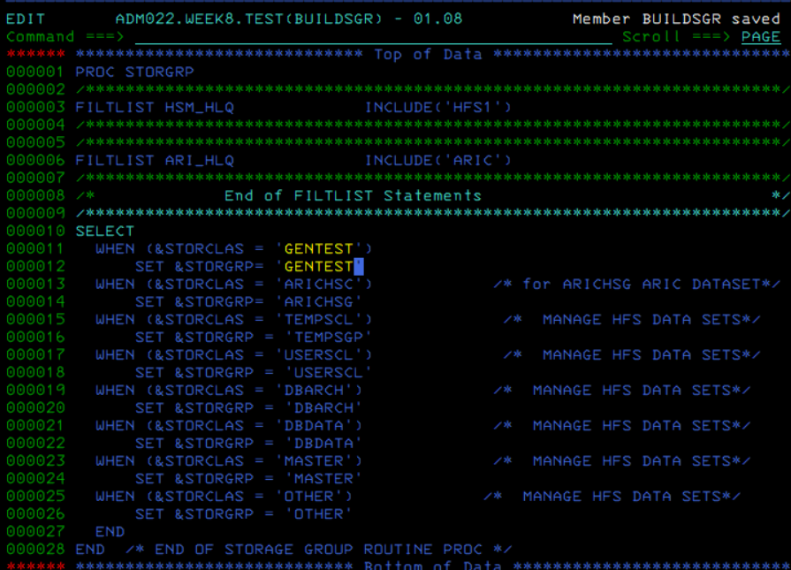

**5) Write an ACS routine for assigning a &DATACLAS**

**1. Assign ADM* -> 'GENUSER'**

**2. Assign GEN*, Second Qualifier as WPR001, First Qualifier as TEST -> DCPDS**

**3. Assign GAMAxy - where x and y can have any alphanumeric value -> DCPSTEST**

**4. Anything else will be NEWONE as DATACLAS**